Download Button

# Why?

There are times when you may wish add a button to the *button* collection at the top of the Content Interface. For example, the *Download* button added in Figure 1. This button can be used to link to any other online resources (e.g. download a PDF file, visit another web page etc.)

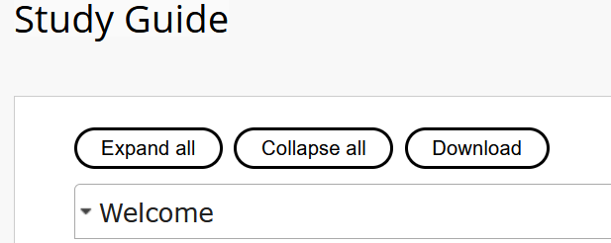

Figure 1 - Example download button added

# What do you need?

To add a download button you need to provide the three values summarised in the following table.

|  |  |
| --- | --- |
| **Variable** | **Purpose** |
| downloadButtonLabel | Defines the text that appears on the label |
| downloadButtonURL | When the button is clicked, it will go to this link |
| downloadButtonTip (*optional*) | A collection of HTML that appears [as a tooltip](https://www.nngroup.com/articles/tooltip-guidelines/) when the visitor rolls their mouse over the button (see Figure 2 for an example) |

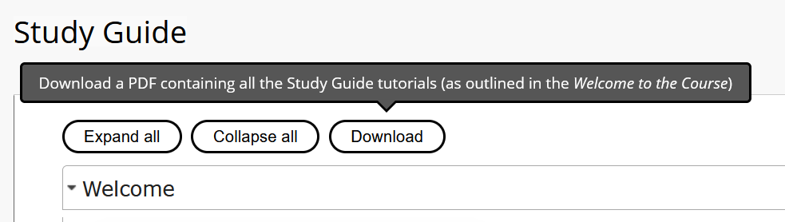

Figure 2 - Showing the tooltip for the download button

# How to add a downloadButton?

To add a download button you add to the appropriate Blackboard page, the values outlined in the above table. The label, URL and (optionally) the tip.

The next table summarises how to add each value. Examples are given in the sections below.

|  |  |
| --- | --- |
| **Variable** | **How to add the value** |
| downloadButtonLabel | Add as a parameter to the name of the *Content Interface* content item. Default value is *Download File* |
| downloadButtonURL | Add a web link item to the page with the name *downloadButtonURL* and the link containing the URL |
| downloadButtonTip | Add a content item to the page with the name *downloadButtonTip*. Enter the HTML for the tip in the content for the item |

The *downloadButtonURL* and *downloadButtonTip* can be quite long, whereas the *downloadButtonLabel* will tend to be fairly short. This is why the label can be set as a parameter, but the URL and Tip have to be additional items on the page.

## downloadButtonLabel

The *Content Interface* item is the item in which the Content Interface content will appear in Blackboard. You can change the label for the download button – from the default value *Download File* – by editing the *Content Interface* item and adding an assignment statement to the name of the item. For example, if with *Edit Mode* on you would see something like Figure 3.

Change the value between the quotes and you change the label displayed on the download button.

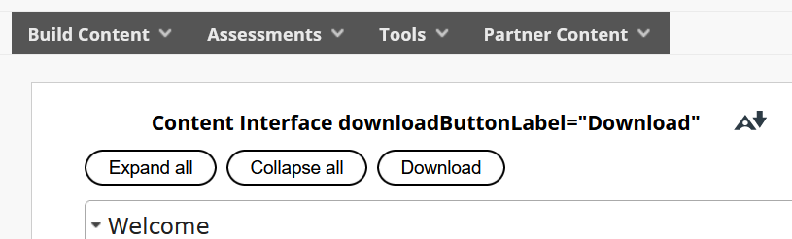

Figure 3 - downloadButtonLabel being assigned a value in the name of the Content Interface item

## downloadButtonURL

When the button is clicked it will attempt to visit the URL (aka link) that you specify as the *downloadButtonURL*. This link can be a file or another web page. Anything you can link to on the web.

To specify the *downloadButtonURL* you add [a web link item](https://help.blackboard.com/Learn/Instructor/Original/Course_Content/Create_Content/Create_Course_Materials/Link_to_Websites) to the Content Area. The name for the web link should be *downloadButtonURL* and the URL for the web link is the URL you wish visited when the button is clicked.

With *Edit Mode* the content area should include a web link item that looks like Figure 4. Figure 5 shows the same web link item being edited.

|  |  |
| --- | --- |
| Figure 4 - web link item configured for downloadButtonURL | Figure 5 - Editing web link item to configure downloadButtonURL |

## downloadButtonTip

*downloadButtonTip* defines a tooltip that will be displayed when the visitor hovers their mouse over the button. Typically intended to be used to provide some additional information that helps the visitor understand the purpose of the button. As shown in Figure 2.

To configure *downloadButtonTip* you should create [a new content item](https://help.blackboard.com/Learn/Instructor/Original/Course_Content/Create_Content/Create_Course_Materials/Create_Content_Items_or_Documents) on the content area page. The name of the new item should be *downloadButtonTip* and the text will be whatever message you wish to display in the tooltip.

Figure 6 shows the *downloadButtonTip* content item for the tooltip shown in Figure 2.

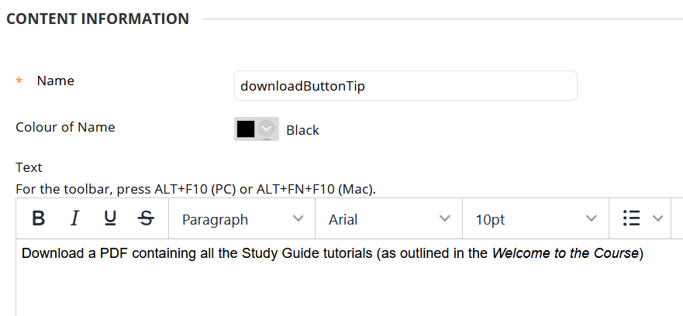

Figure 6 - Configuring the download button tool tip shown in Figure 2